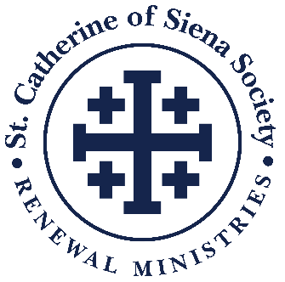

Bequest Language for Estate Planning Documents

Bequest

A bequest in which you leave Renewal Ministries a specific dollar amount or specified assets, such as securities, real estate, or tangible property is considered unrestricted and is intended for general support of Renewal Ministries at the discretion of the President and Board of Directors.

Consider using the following language when you create your will or trust, or you may add a codicil (addendum) to your existing will or trust:

Choose the appropriate country:

In the United States use this formula:
"I give and bequeath to Renewal Ministries Inc., P.O. Box 491, Ann Arbor, MI 48106-0491, Tax ID 38-2385975"

In Canada use this formula:
"I give and bequeath to Catholic Renewal Ministries Inc., 80 Jutland Rd, Unit 1500, Etobicoke, ON M8Z 2H1, Registration No. 123740243RR0001”

One of the above along with:

a. The sum of $________;
b. ________% of my estate;
c. The following securities, real estate, or tangible property ____________,
d. Or, ________% of the remainder of my estate after specific amounts are bequeathed to other
beneficiaries and estate-related expenses are paid.

Beneficiary Designations

Donors may designate Renewal Ministries as the beneficiary of their IRA, life insurance policy, investment account, or qualified retirement plan. Beneficiary forms are available by contacting the organization that manages your accounts or insurance policy.

The following language can be used on the beneficiary form:

In the United States In Canada
Renewal Ministries Inc. Catholic Renewal Ministries Inc.
P.O. Box 491 80 Jutland Rd, Unit 1500
Ann Arbor, MI 48106-0491 Etobicoke, ON M8Z 2H1
Tax ID 38-2385975 Registration No. 123740243RR0001-

